Example A: (AND Gate using NAND)
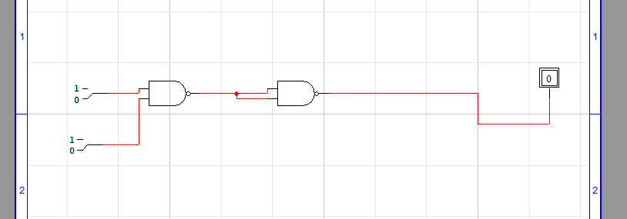
Truth Table:
A | B | F | F’(NAND)
0 | 0 | 0 | 1
0 | 1 | 0 | 1
1 | 0 | 0 | 1
1 | 1 | 1 | 0
Expression:
F’ = (A.B)’’
Example B: (OR GATE USING NAND)
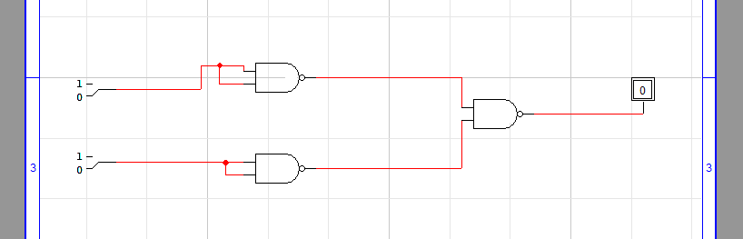
Truth Table:
A | B | A’ | B’ | F (A’.B’)’
0 | 0 | 1 | 1 | 0
0 | 1 | 1 | 0 | 1
1 | 0 | 0 | 1 | 1
1 | 1 | 0 | 0 | 1
Expression:
(A’ . B’)’ = A+B F= (A’.B’)’
Example C: (Not Gate using NAND)
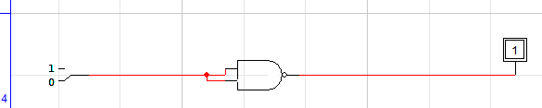
Expression:
C= (A.A)’
Truth Table:
A | A | C (A.A)’
0 | 0 | 1
1 | 1 | 0

Example 4 : (AND Gate using NOR)
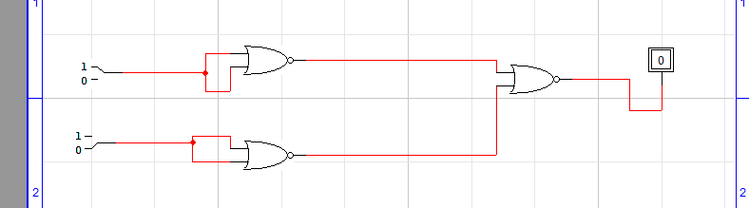
Expression:
(A’+B’)’
Truth Table:
A | B | A’ | B’ | C (A’+B’)’
0 | 0 | 1 | 1 | 0
1 | 0 | 0 | 1 | 1
0 | 1 | 1 | 0 | 1
1 | 1 | 0 | 0 | 1

Example 5 : (OR GATE USING NOR)
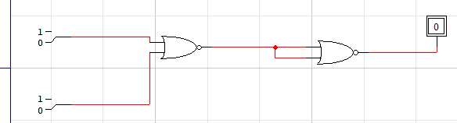
Expression:
C=(A+B)’’
Truth Table:
A | B | (A+B)’ | C (A+B)’’
0 | 0 | 1 | 0
0 | 1 | 0 | 1
1 | 0 | 0 | 1
1 | 1 | 0 | 1

Example 6 : (NOT GATE USING NOR)
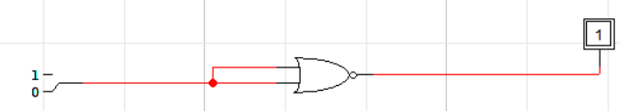
Expression:
C = (A+A)’
Truth Table:
A | C (A+A)’
0 | 1
1 | 0

TASK 1:
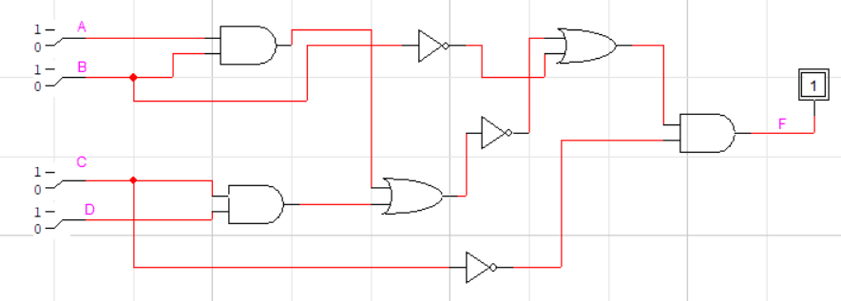
Expression:
F = ((A.B + C.D)’+ B’).(C’))

Truth Table:
A | B | C | D | A.B | C.D | (A.B+C.D)’ | C’ | F
0 | 0 | 0 | 0 | 0 | 0 | 1 | 1 | 1
0 | 1 | 0 | 0 | 0 | 0 | 1 | 1 | 1
1 | 0 | 0 | 0 | 0 | 0 | 1 | 1 | 1
1 | 1 | 0 | 0 | 1 | 0 | 0 | 1 | 0
0 | 0 | 1 | 0 | 0 | 0 | 1 | 0 | 0
0 | 1 | 1 | 0 | 0 | 0 | 1 | 0 | 0
1 | 0 | 1 | 0 | 0 | 0 | 1 | 0 | 0
1 | 1 | 1 | 0 | 1 | 0 | 0 | 0 | 0
0 | 0 | 0 | 1 | 0 | 0 | 1 | 1 | 1
0 | 1 | 0 | 1 | 0 | 0 | 1 | 1 | 1
1 | 0 | 0 | 1 | 0 | 0 | 1 | 1 | 1
1 | 1 | 0 | 1 | 1 | 0 | 0 | 1 | 0
0 | 0 | 1 | 1 | 0 | 1 | 0 | 0 | 0
0 | 1 | 1 | 1 | 0 | 1 | 0 | 0 | 0
1 | 0 | 1 | 1 | 0 | 1 | 0 | 0 | 0
1 | 1 | 1 | 1 | 1 | 1 | 0 | 0 | 0

TASK 2:
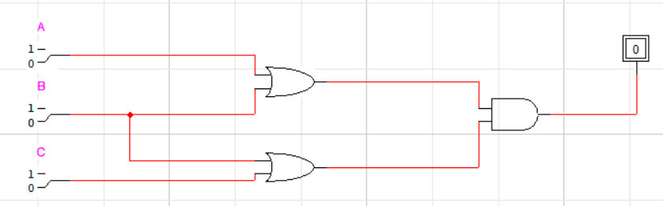
Expression:
F=(A+B).(B+C)

Truth Table:
A | B | C | A+B | B+C | F
0 | 0 | 0 | 0 | 0 | 0
1 | 0 | 0 | 1 | 0 | 0
0 | 1 | 0 | 1 | 1 | 1
1 | 1 | 0 | 1 | 1 | 1
0 | 0 | 1 | 0 | 1 | 0
1 | 0 | 1 | 1 | 1 | 1
0 | 1 | 1 | 1 | 1 | 1
1 | 1 | 1 | 1 | 1 | 1

TASK 3 (1):
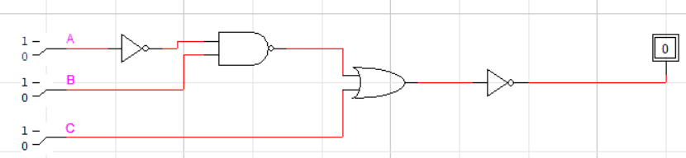

Boolean Expression:
F= ((A’.B)’+C)’
Truth Table:
A | B | C | A’ | (A’.B)’ | F
0 | 0 | 0 | 1 | 1 | 0
1 | 0 | 0 | 0 | 1 | 0
0 | 1 | 0 | 1 | 0 | 1
1 | 1 | 0 | 0 | 1 | 0
0 | 0 | 1 | 1 | 1 | 0
1 | 0 | 1 | 0 | 1 | 0
0 | 1 | 1 | 1 | 0 | 0
1 | 1 | 1 | 0 | 1 | 0
Task 3 (2):
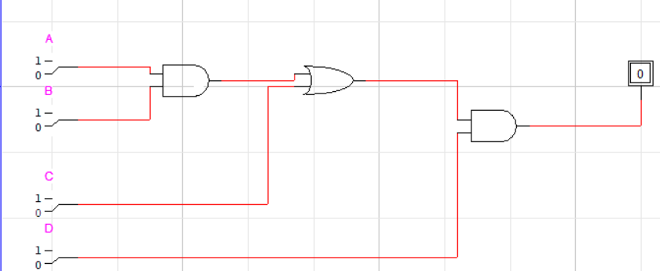
Expression:
F = (A.B + C).D
Truth Table:
A | B | C | (A.B) + C | F
0 | 0 | 0 | 0 | 0
0 | 0 | 1 | 1 | 0
0 | 1 | 0 | 0 | 0
0 | 1 | 1 | 1 | 0
1 | 0 | 0 | 0 | 0
1 | 0 | 1 | 1 | 0
1 | 1 | 0 | 1 | 0
1 | 1 | 1 | 1 | 1

Task 3(3):
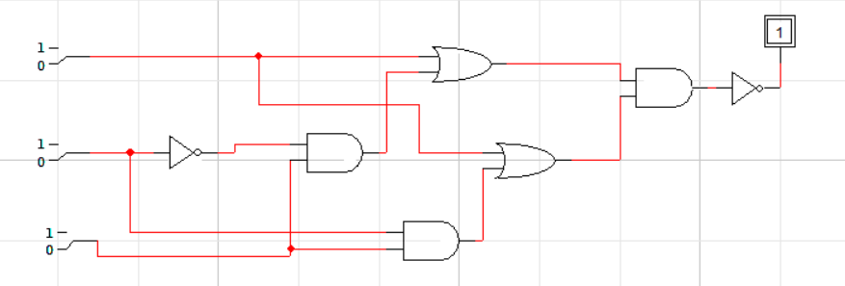
Expression:
F = ((A + B’C)(A + BC))’
Truth Table:
A | B | C | B' | BC | B'C | A + B'C | BC + A | (A + B'C)(A + BC) | F
0 | 0 | 0 | 1 | 0 | 1 | 1 | 0 | 0 | 1
0 | 0 | 1 | 1 | 1 | 0 | 1 | 1 | 1 | 0
0 | 1 | 0 | 0 | 0 | 0 | 0 | 0 | 0 | 1
0 | 1 | 1 | 0 | 1 | 0 | 0 | 1 | 1 | 0
1 | 0 | 0 | 1 | 0 | 1 | 1 | 1 | 1 | 0
1 | 0 | 1 | 1 | 1 | 0 | 1 | 1 | 1 | 0
1 | 1 | 0 | 0 | 0 | 0 | 1 | 1 | 1 | 0
1 | 1 | 1 | 0 | 1 | 0 | 1 | 1 | 1 | 0
TASK 3(4):
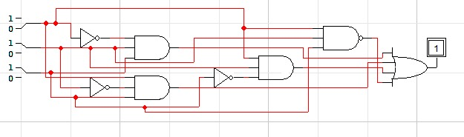

Boolean Expression:
F= A’BC + AB’C + ABC’ + (ABC)’
Truth Table:
A | B | C | A' | B' | C' | A'BC | AB'C | ABC' | (ABC)’ | F
0 | 0 | 0 | 1 | 1 | 1 | 0 | 0 | 0 | 1 | 1
0 | 0 | 1 | 1 | 1 | 0 | 0 | 0 | 0 | 1 | 1
0 | 1 | 0 | 1 | 0 | 1 | 0 | 0 | 0 | 1 | 1
0 | 1 | 1 | 1 | 0 | 0 | 1 | 0 | 0 | 1 | 1
1 | 0 | 0 | 0 | 1 | 1 | 0 | 0 | 0 | 1 | 1
1 | 0 | 1 | 0 | 1 | 0 | 0 | 1 | 0 | 1 | 1
1 | 1 | 0 | 0 | 0 | 1 | 0 | 0 | 1 | 1 | 1
1 | 1 | 1 | 0 | 0 | 0 | 0 | 0 | 0 | 0 | 0
Task 3(5):
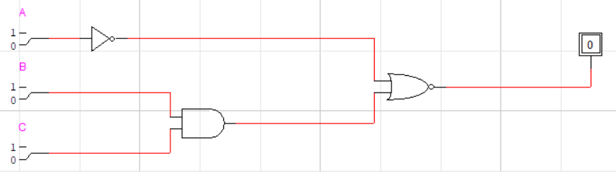
Expression:
F = (A’ + BC)’
A | B | C | A' | A’+BC | F
0 | 0 | 0 | 1 | 1 | 0
0 | 0 | 1 | 1 | 1 | 0
0 | 1 | 0 | 1 | 1 | 0
0 | 1 | 1 | 1 | 1 | 0
1 | 0 | 0 | 0 | 0 | 1
1 | 0 | 1 | 0 | 0 | 1
1 | 1 | 0 | 0 | 0 | 1
1 | 1 | 1 | 0 | 1 | 0

Task 4: (Task 1 conversion using Nand & Nor Only)
